06.3

STUDENT MODULE EVALUATION POLICY (INCLUDING MODULE EVALUATION FORM: COLLABORATIVE PROVISION)

CARDIFF METROPOLITAN UNIVERSITY

Policy on Student Evaluation of Modules

Introduction

To ensure that the University maintains a high quality student experience it is essential that all students have an opportunity throughout their study to reflect upon and evaluate their experience.

The University has a range of formal and informal mechanisms for collecting student feedback including programme committees, staff/student liaison committees and student involvement in curriculum approval; this policy is concerned with student evaluation of modules. The term module throughout this policy is taken to apply to all course units, even where the term module is not used.

Key Principles

- The primary purpose of student module evaluation is to assure the quality of learning, teaching and assessment and to enhance the student experience.

- Student module evaluation must be conducted within strict ethical guidelines.

- The methods used should not disadvantage any student from participating.

- Feedback gathered from students must be responded to on a timescale appropriate to student needs.

- Actions taken in response to feedback from students must be communicated within an agreed timescale to students.

- Promotes self- assessment by the student.

Policy

The main purpose of student module evaluation is to enhance the student learning experience in order to make continuous improvements to levels of student satisfaction and student success as measured through retention, progression and achievement. It seeks feedback for programme directors and module leaders and does not seek student opinion on the wider student experience.

The policy applies to all taught undergraduate and postgraduate modules, including work-based learning modules, whether offered as credit bearing short courses or as part of a programme leading to a University award. The policy does not apply to modules offered as part of degrees classified as research or falling under the scope of the Research Degrees Committee.

This policy, and a University template evaluation form for collaborative provision (Appendix 3), is also circulated to partner institutions. Although it is recognised that partners may have their own methods for student module evaluation in place (which will be assessed as part of the validation process), the expectation is that the core areas covered below will be included in any evaluation form. The template evaluation form is provided to partners for information, and partners may choose to adopt the form. The policy and template must be adopted where partners do not practice student module evaluation.

Student module evaluation involves mechanisms for measuring student satisfaction with their experience, which are used to inform quality enhancement at module, course and University level. Schools must follow the institutional model (Appendix 1) for the evaluation of all modules each time they are run and for the objective analysis and scrutiny of outcomes. Guidance for the suite of evaluation methods is available in Appendix 2.

Schools must have a clear policy statement on module evaluation, to be made available to students, which includes policy on reporting of module evaluation results and acting upon and communicating them, and a response to students who completed the evaluation.

The model includes a number of requirements of the Programme/School throughout the process

- Schools ensure that they use methods from within the suite of evaluation methods outlined in the model
- Schools ensure that modules are evaluated mid-term, reflected upon with outputs documented, which are also evaluated at the end of the module
- Module Leaders are responsible for the completion of the Staff Module Review Summary and forwarding of the summary form to Programme Directors, the form should include the following sections:
  - Mid – module reflection
    - Collection Method chosen
    - Number of responses
    - Key Strengths and Area for improvement
    - Actions to be taken in response to evaluation
  - End of Module Evaluation
    - Collection Method chosen
    - Number of Responses
    - Effect of actions taken mid-term
  - Actions to be taken forward
  - You said – we did commentary

- Schools ensure that students are provided with timely information about the outcomes of module evaluation on an ongoing basis.

- Schools ensure that module evaluation outcomes are discussed at programme committees with student representatives.

- Programme directors are responsible for forwarding the module evaluation results through the Staff Module Review Summary to the Deputy/Associate Dean to inform their APR Review Report

- Student Module Evaluation results feed into the Annual Programme Review (APR) process.

The Learning & Teaching Committee must receive a section within the Deputy Dean of Learning and Teaching’s review of Annual Programme Reports covering:

- Key Institutional Themes

- Response Rates

- Effectiveness of Administration

- Response to Issues

- Outstanding Actions

The Quality Enhancement Directorate provides guidance to Schools and course teams on effective ways of managing and responding to student feedback and module evaluations.

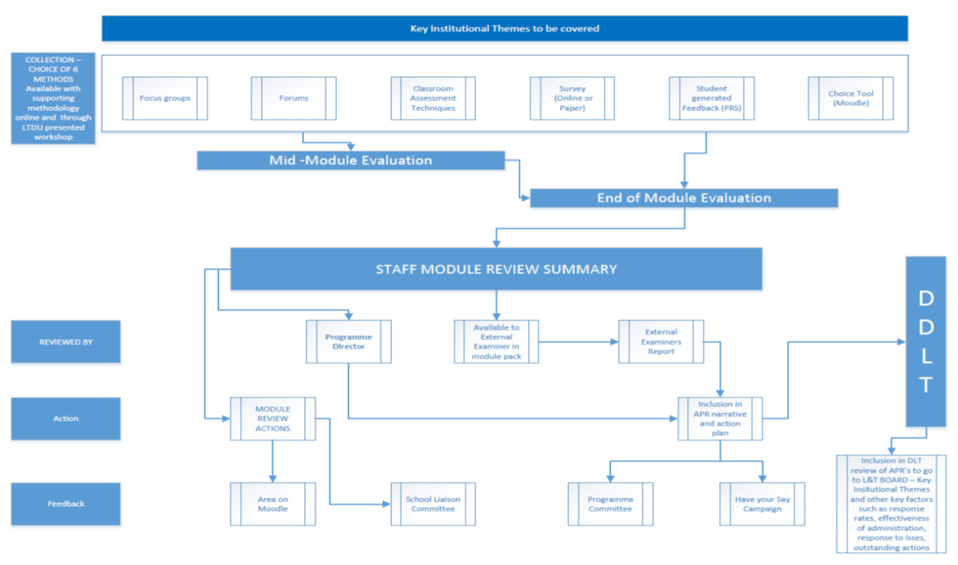

Appendix 2

Module Evaluation
Assessing the Options
Questionnaires are the most common means of obtaining feedback from students about their modules (Brennan, 2004) but there have been attempts to experiment with other methods due, not least to efforts to address low response rates. We also wanted to promote some flexibility in gaining module feedback from students to account for different class sizes, the nature of the module and to provide opportunities for on-going evaluation of student learning. At Cardiff Metropolitan, we have decided to focus on 6 potential methods:
- Focus Groups
- Forum
- Classroom Assessment Techniques and PRS
- Survey
- Development PRS (student generated)
- Choice Tool on Moodle
These methods will be outlined below, together with advantages and disadvantages for the use of each method. We trust that this will be helpful in making your choice.

Focus Groups
In June 2015, a report on Instant students’ feedback on teacher practices, within the FE sector, found that those that generated the best feedback rates included focus groups and course representative feedback, as well as online surveys. A report by an American company engaged in harvesting feedback from social media, emphasized the need to supplement online feedback with face-to-face methods.

Advantages
- Provides an opportunity for dialogue
- Non-verbal communication can give valuable information
- Issues of concern can be raised and discussed in depth
- Ideas can be tested
- May provide students with the opportunity for development
- Actions can be taken quickly

Challenges
- Making time available for participation and analysis
- Ensuring representative selection of participants
- Facilitating discussion fairly
- Safeguarding confidentiality
Focus groups can be particularly useful where there are specific issues to discuss. It can be difficult to meet those challenges of appropriate representation with large groups of students. Why not try using focus groups as a supplement to other methods? Forming focus groups following on from classroom surveys, where each individual represents a view that has arisen, might work well.

Forum
Forums can be used as a formal alternative to questionnaires, with individual questions set at intervals or can be informal with feedback being received from students as issues arise. Even if a forum is structured, it is possible that it may lead to more in-depth discussions if particular questions attract interest.

Advantages
- Dialogue can be ongoing
- There is an online record of how the discussion has progressed
- Dominant or aggressive participants can be identified swiftly
- Reluctant participants may be encouraged by an online environment
- Tutors can respond quickly if issues are of particular concern

Challenges
- Ensuring that students are motivated to participate
- Moderating online discussion and avoiding ‘flame wars’
Online forums can be particularly useful with large groups where individuals could easily be ‘invisible’ in an open discussion. In order to work successfully they require good preparation and frequent responses. You might like to consider these for motivating students to respond in the forum:
- Use a light-hearted ice-breaker question and volunteer an answer yourself
- Post a recording (video or audio) of someone talking about some aspect of the module and ask if they agree with the view expressed
- Post the result of a previous survey and what was done about an issue raised
In all these cases the students need to access the forum for information and this might encourage them to respond.
It’s also important to outline expectations from the start including:
- Acceptable behaviour and language style
- The objective of the forum
- Encouraging a sense of ease where there are no right or wrong answers
Additional suggestions about preparing and using online forums can be found in the Mastering Moodle Online module, under Social Tools in Focus on Forums.
Instructions on how to set up forums can be found in the same section in Creating a Moodle Forum.

Classroom Assessment Techniques and Personal Response Systems
Classroom assessment techniques can be adapted to gain more general feedback information about the module.

Advantages
- Feedback is rapid and issues can be addressed rapidly
- Allows more reticent individuals to express their opinions easily
- Some methods (especially when used with PRS) can be suitable for large groups
- Some methods, such as Application Cards, draw attention to the relevance of learning

Challenges
- Individuals may be influenced by the opinion of others
- Differentiating between things which are complex in nature and those which could be presented more clearly
- An instantaneous response may give rise to a lack of reflection
- Responses may be subject specific

Some classroom-based activities might include:

Traffic Lights
Give the students three post-it notes in different colours (e.g. red, orange & green)
Ask them to choose three things; one which they didn’t understand, one which needed further clarification and one which they understood thoroughly. They should write each one on an appropriately coloured post-it note (e.g. red for a lack of understanding) and add any questions which they still need answered.

Application Cards
Ask students to write about how they could apply what they have just learned to a real world situation. This helps to clarify the relevance of what they are learning and relate it to prior knowledge. Later staff can share examples, discuss or initiate group work. (Taken from Angelo & Cross (1993))

Minute Paper
In the last five minutes of class, ask the students a question such as “What was the most important thing that you learned during class?’ or ‘What important question remains unanswered?’. Collect the feedback and address any problem points at the beginning of the next class. (Taken from Angelo & Cross (1993))

Muddiest Point
At the end of a lecture, discussion or other activity ask students to answer the question ‘What was the muddiest point in…?’ The students then have to identify what they have not understood immediately and staff learn what students find most difficult enabling them to clarify it. (Taken from Angelo & Cross (1993))
All these methods, as well as the use of Personal Response Systems, can give tutors immediate feedback which can lead into further discussion.

Survey
Little appears to have changed since 2004 when Brennan noted that ‘questionnaires are by far the most commonly used mechanism’ for gaining student feedback.

Advantages
- Consistency of results across the institution
- Quick and easy to administer (particularly online)
- Completed individually, so less likelihood of peer pressure

Challenges
- Students receive a number of surveys and may begin to suffer ‘survey fatigue’
- Drafting multiple choice questions can be complex
- Lack of opportunity for in depth discussion
Surveys are most useful when supplemented by other methods that provide an opportunity for staff/student interaction and allow issues to be addressed promptly and visibly.

Student-generated feedback using the PRS
This is a method whereby students generate a list of responses and use the PRS system to vote on them thereby prioritising their feedback for the module
In small groups, students generate a list in response to a tutor-led question. This might include what they found most helpful in promoting their learning, what resources they had most frequently used etc. Staff type the responses into the TurningPoint, PowerPoint presentation slides and then ask students, by using the PRS clickers, to identify the answer that sits at the top of their individual thinking.
This generates a graph, which highlights the priorities as identified by the students and promotes wider thinking. The visual representation allows students to anonymously see where they sit in relation to their student group.

Advantages
- Generates collective thinking similar to focus groups
- Enables students to judge their thinking against that of the cohort
- Can be used with large groups

Challenges
- Requires the right equipment
- May be difficult to manage in large student cohorts to maintain control
- Limited in-depth discussion

Choice Tool on Moodle
The Choice Tool on Moodle allows a single question to be asked, with multiple possible answers. The student selects one, or more if allowed, of the answers to the question. The staff can then see the number of selections for each answer. The results can be displayed anonymously or otherwise, depending on the way the activity has been set up.

Advantages
- It can be used both in or outside of class
- It can provide quick responses
- The questions can be set up in advance and made available at intervals

Challenges
- If done outside of contact time, motivation may be an issue
- Setting up a number of choice activities involves an investment of time
Ideas about using the Choice Tool can be found in Mastering Moodle Online, under ‘How can I include Activities?’ in ‘Choice’ is Endless and instructions on Creating a Choice Activity can be found in the same section.
APPENDIX 3

Module Evaluation Form: Collaborative Provision

The purpose of this student evaluation is to enable staff to monitor and revise the effectiveness of the programme, programme component or module that they teach. Please think carefully about your responses and wherever appropriate, provide additional information to enable tutors to improve programme provision. Please circle the appropriate number to indicate your response. If you wish, you may also add a brief comment underneath each of the questions. On completion, please return this evaluation form to your Programme/Module Leader.

Today’s date:
Programme Title: | Year of study:
Aspect of the programme/name of module being evaluated:

Name of Programme/Module Leader (as appropriate):

With the exception of Q. 12, please use the following grade descriptions when responding to questions:
1=Very Good, 2=Good, 3=Satisfactory, 4=Unsatisfactory
- Please rate the standard of teaching on the programme/module in enabling you to attain the learning outcomes.

VG | G | S | US
1 | 2 | 3 | 4

- To what extent was the programme/module appropriately structured?

VG | G | S | US
1 | 2 | 3 | 4
- Please comment on the relevance of the subject matter in furthering your professional development.

VG | G | S | US
1 | 2 | 3 | 4

- How effective were the assessment methods employed in identifying your strengths and areas for future development?

VG | G | S | US
1 | 2 | 3 | 4
- How effectively were the learning outcomes and assessment model communicated to you?

VG | G | S | US
1 | 2 | 3 | 4

- How effective was the programme/module in allowing you to develop at your own level of ability?

VG | G | S | US
1 | 2 | 3 | 4

- How effective was the programme/module in raising your overall professional development?

VG | G | S | US
1 | 2 | 3 | 4

- Please rate the quality of programme/module materials.

VG | G | S | US
1 | 2 | 3 | 4

9. With reference to the programme/module, please rate the quality of:
i) the accommodation:

VG | G | S | US
1 | 2 | 3 | 4

ii) the ICT facilities:

VG | G | S | US
1 | 2 | 3 | 4

iii) the library resources.

VG | G | S | US
1 | 2 | 3 | 4

10. In relation to this programme/module, how effective did you find Moodle as a learning resource?

VG | G | S | US
1 | 2 | 3 | 4

11. How effective was Moodle in helping you to achieve the learning outcomes?

VG | G | S | US
1 | 2 | 3 | 4

12. How frequently did you access Moodle during the programme/module?
(F = frequently; FF = fairly frequently; O = occasionally; N = never)
F | FF | O | N
1 | 2 | 3 | 4

13. Please rate the overall success of the programme/module.

VG | G | S | US
1 | 2 | 3 | 4

Please use the space below to add any bullet pointed comments highlighting strengths and areas for improvement of the module. If you have rated any of the above as being 4, you must supply your reasons for this.

