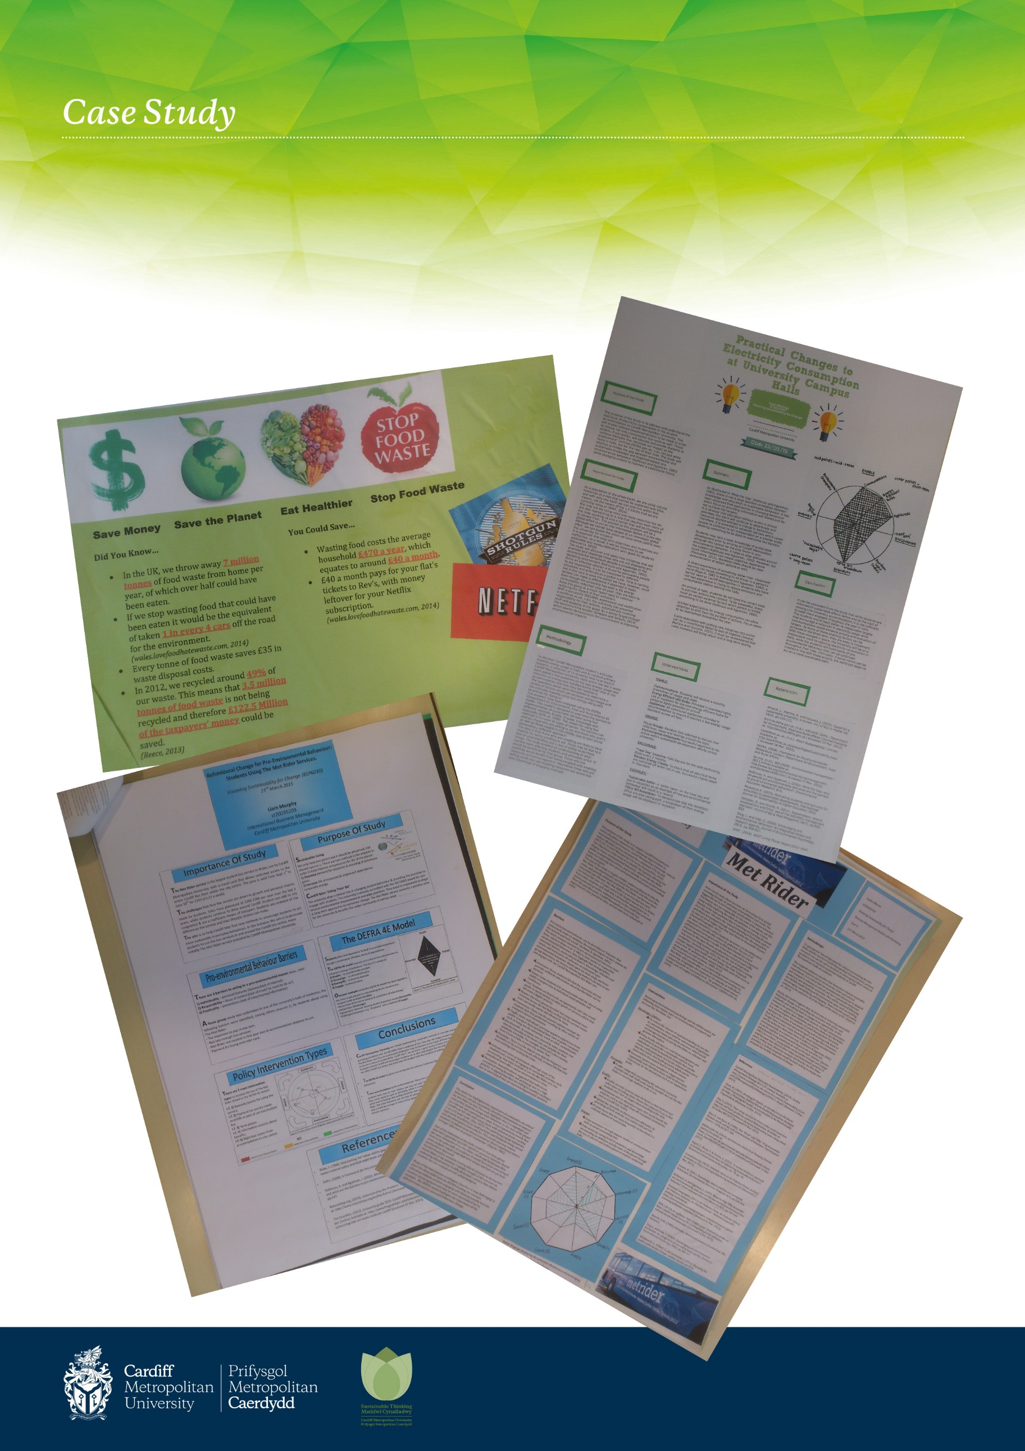

Visioning Sustainability for Change 2014-15

