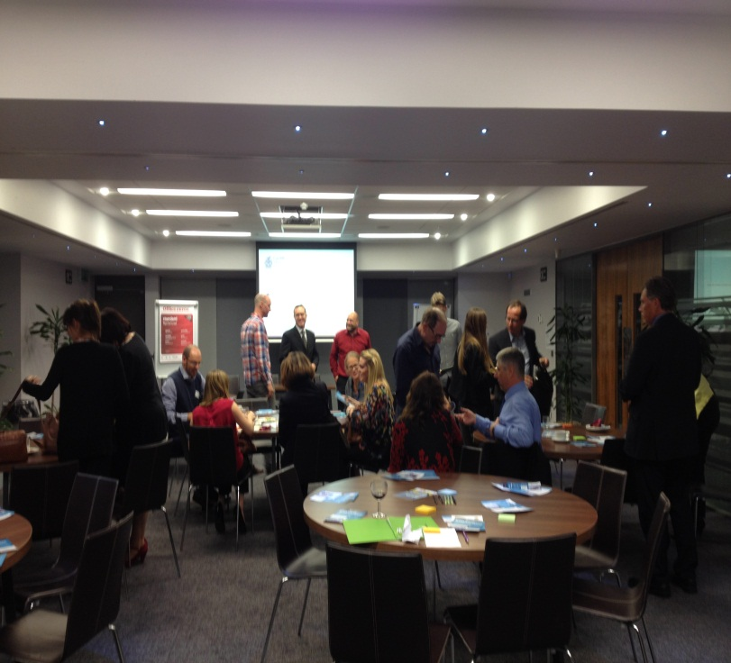

Nurturing local ‘Sustainable Development and Eco Innovation’ relationships at Cardiff Met
Cardiff Metropolitan University recently held a collaborative networking event to develop practical relationships between the University and local businesses for sustainable development and eco innovation.

The collaborative event held this week, between the EcoDesign Centre, Cynnal Cymru – Sustain Wales and Cardiff Metropolitan’s Learning, Teaching and Development Unit came together at Cardiff Met’s School of Management to discuss ‘Educate and Innovate: Opportunities for professional and business development in the field of sustainability’ .
A range of successful collaborations have occurred to date, some include: Welsh Government and Innovate UK funding schemes available to regional businesses; Two Cardiff Met accredited short courses in the field of sustainability as it relates to business strategy and project management; Opportunities for businesses to collaborate with Cardiff Met students via live projects and student placements and collaborative research schemes.
The event was a great success with delegates in attendance from the Welsh Government Innovation Team, the Principality Building Society, Melin Homes, Odoni-Elwell, the Millennium Stadium, Tidal Lagoon Power and EEEsafe.
If you are interested in any of the above please get in touch with Stuart Abbott (Learning Development Officer) who will be happy to put you in touch with relevant contacts. sabbott@cardiffmet.ac.uk or x 5736.

September 8th 2015

